1) ________________ aimed to evaluate the compliance of a system or component with specified functional requirements.

A) Integration Testing

B) System Testing

C) Unit Testing

D) User Acceptance Testing

2)______________________ displays only records that meet a specific condition or conditions and useful when the user wants information that might require action but does not need to know the details.

A) Exception report

B) Summary report

C) Detail report

D) Technical report

3)______________________ lists specific input numbers a program would typically expect the user to enter and precise output values that a perfect program would return for those input values.

A) Test plan

B) Error handler

C) Design specification

D) Input-output specification

4) ‘Maintenance and training fees’ would be classified as __________________.

i.        Developmental cost

ii.      Operational cost (payroll,rent, utilities)

iii.    Direct cost

iv.    Indirect cost

A) ii, iv

B) ii, iii

C) i, iv

D) i, ii

5)‘Minimize Coupling’ is one of the good programming principles to ensure ___________________.

A) Any section of code should diminish the dependencies on other areas of code.

B) A component of code should perform a single well-defined task.

C) Each significant piece of functionality in a program should be implemented in just one place in the source code.

D) A code that has similar functionality should be found within the same component.

6)“Company XYZ would like to propose a new system. They need a specific measurement that will help them to determine if the project is doable. ”WHICH OF THE FOLLOWING METHOD IS SUITABLE FOR ABOVE MENTION SITUATION?

A) Preliminary Investigation

B) Brainstorming Session

C) SWOT Analysis

D) User Acceptance

7)“Create a specific timetable that shows tasks, task dependencies, and critical tasks that might delay the project.”The statement above is related to the following roles of Project Manager.

A) Project Scheduling

B) Project Planning

C) Project Monitoring

D) Project Reporting

8) Software entities (classes, modules, functions, etc.) should be open for extension but closed for modification is referring to ______________ principal.

A) Open/ Close

B) Keep It Short and Simple (KISS)

C) Don’t Repeat Yourself (DRY)

D) Loose coupling

9)Suppose you are running a web application and you found that it is not compatible with a new version of Microsoft web browser (powered Edge browser). To address this compatibility issue in your web application is a part of _________________.

A) Adaptive Maintenance

B) Perfective Maintenance

C) Preventive Maintenance

D) Corrective Maintenance

10)What does the **‘sink’** means in a data flow diagram (DFD)?

A) An external entity that receives data.

B) An external entity that supplies data.

C) An external entity that supplies and receives data.

D) An external entity that modifies data.

11)Which of the following is _TRUE_ about Physical Design?

A) Concerned with how the requirements are satisfied and how the data is input

B) Concerned with what is required and how the data is input

C) Concerned with what is required and what processes must be performed

D) Concerned with how the requirements are satisfied and what information will be output

ESSAY QUESTION

**Suggested Answer**

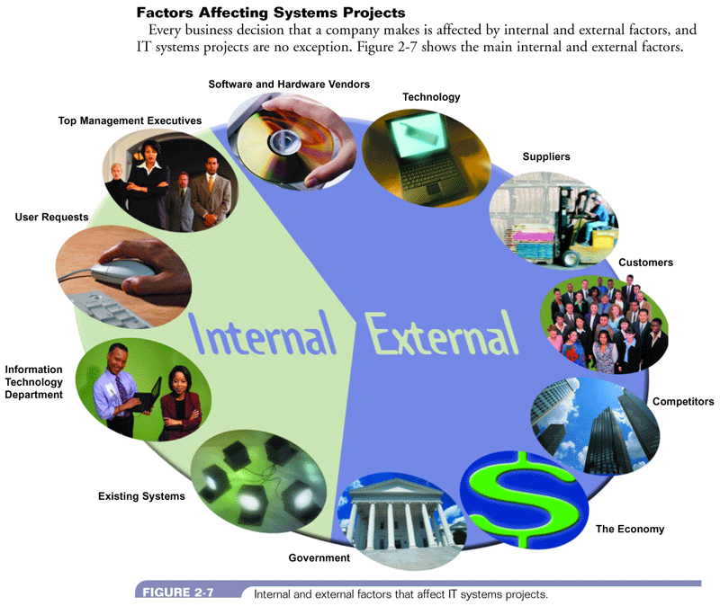

**Suggested Marking Scheme:**

* ***Identify 4 different factor affecting system request 1 mark (1 mark x 4 factor = 4 marks)***
* ***Explain in detailed of 1 factor affecting system request (1 mark x 4 factor = 4 marks)***

***Total = 8 Marks***

**Suggested Answer**

(Accept any logical assumptions with the given format)

Data dictionary for an **external entity**

* Entity name: The entity name as it appears on the Context Diagram.
* Description: Describe the entity and its purpose.
* Input data flows: The standard names for the input data flows to the entity.
* Output data flows: The standard names for the data flows leaving the entity.

Dictionary for a **data flow**

Name The data flow name as it appears on the Context Diagram.

* Description: Describes the data flow and its purpose.
* Origin / Source: The beginning or source of the data flow.
* Destination: The ending points for the data flow.
* Data structure: Also known as a record.

**Suggested Marks**

* *Award 5 marks for each correct component*
* *Ensure data structure format is correct*
* *Ensure data element description is logical*

**Suggested Answer**

* Unit Testing
* The testing of an individual program or module
* Objective is to identify and eliminate execution errors that could cause the program to terminate abnormally, and logic errors that could have been missed during desk checking
* Test data should contain both correct data and erroneous data and should test all possible situations that could occur
* Integration Testing
* Testing two or more programs that depend on each other to make sure that the programs work together properly
* System Testing
  + Verify that all system components are integrated properly and that actual processing situations will be handled correctly
  + Confirm that the information system can handle predicted volumes of data in a timely and efficient manner
* ***Identify 3 type of testing - each testing 1 marks (1 mark x 3 strategies = 3 marks)***
* ***Maximum of 1 marks for the explanation of each testing (2 marks x 3 strategies = 6 marks)***
* ***Total 9 marks***

**Suggested Answer**

*Award 2 marks for each correct test plan*

System Change-over Strategies is about how the old system will be replaced with a new system.

Any FOUR (4) system change-over strategies:

* **Direct Cutover**
  + - Where the old system is cut and overwritten by the new system. The direct cutover approach causes the changeover from the old system to the new system to occur immediately when the new system becomes operational.
* **Parallel Operation**
  + - The new system runs concurrently with the old for a given period.
    - Of all the techniques, this tends to be the most popular, mainly because it carries the lowest risk.
    - If something goes wrong at any point, the entire system can be reverted to its original state.
    - A primary disadvantage in running two systems at the same time is higher costs and time-consuming.
* **Pilot Operation**
  + - The new system is tried out at a test site before launching it company-wide.
    - Since parallel changeovers tend to be expensive, using the pilot changeover technique allows companies to run the new system next to their old but on a much smaller scale.
    - This makes the pilot changeover method much more cost-effective.
    - After the kinks are worked out of the system at the test site, companies usually opt to use the direct changeover technique to launch the system company-wide.
* **Phased Operation**
  + - The phased changeover technique is considered a compromise between parallel and direct changeovers.
    - In a phased changeover, the new system is implemented one stage at a time. As an example, consider a company working toward installing a new financial system.
    - Implementing the new system one department at a time, the company converts accounts receivable, accounts payable, payroll, and so on.
    - Advantages to phased changeovers are their low cost and isolated errors.
    - The main disadvantage is the process takes a long time to complete because phases need to be implemented separately.

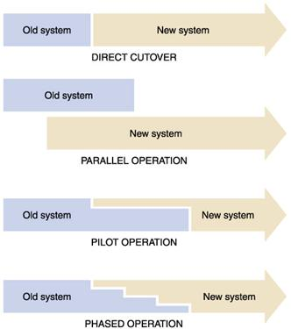

*Any sensibly related answer that can match with the case study is acceptable.*

**Suggested Marking Scheme:**

* ***Definition of system change-over (1 mark)***
* ***Identify 4 different strategies - each strategy 1 mars (1 mark x 4 strategies = 4 marks)***
* ***Maximum of 1 marks for the explanation of each strategy (1 marks x 4 strategies = 8 marks)***
* ***Total 8 marks***